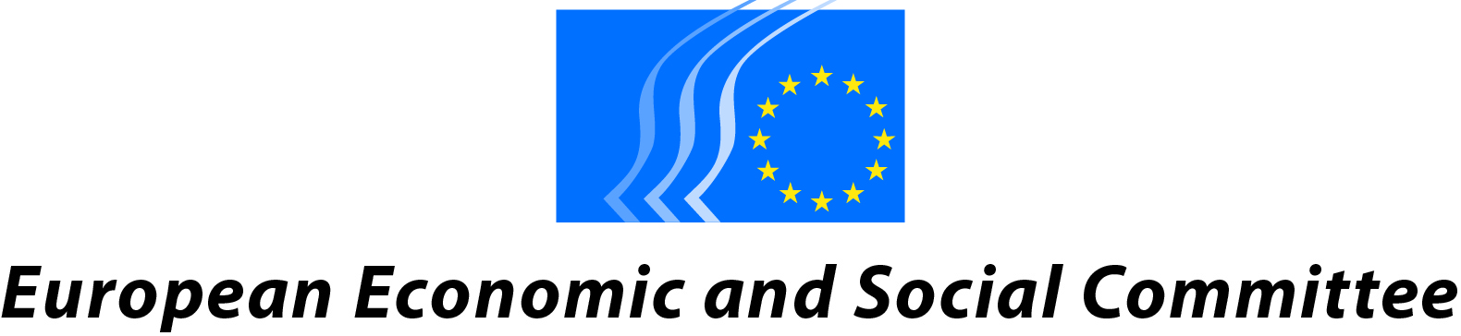

ANNUAL MEETING OF THE PRESIDENTS AND SECRETRARIES-GENERAL
OF THE ECONOMIC AND SOCIAL COUNCILS OF THE EU
AND THE EUROPEAN ECONOMIC AND SOCIAL COMMITTEE

MALTA, 22 AND 23 JUNE 2017
Corinthia Palace Hotel, Attard

Programme
TOWARDS A FAIR AND INCLUSIVE LABOUR MARKET
IN THE CONTEXT OF INTRA-EU MOBILITY

Thursday, 22 June 2017
09:30 am | Arrival and registration of participants
09:45 am | Opening of the meeting  - John Bencini, Chairman of the MCESD  - Georges Dassis, President of the EESC  - Helena Dalli, Hon Minister for European Affairs and Equality
10:15 am | Discussion Session  Contributions of the ESCs of:  France, Belgium (CNT & CCE), Bulgaria, Czech Republic and Luxembourg  Debate
12:30 pm | Lunch
02:00 pm | Discussion Session  Contributions of the ESCs of:  Italy, Ireland, Greece and Spain  Debate
04:00 pm | End of the first day
04:30 – 07:00 pm | Trip to Mdina (guided tour)
07:30 pm | Dinner at Palazzo Castelletti

Friday, 23 June 2017
09:00 am | Discussion Session  Contributions of the ESCs of:  Hungary, Malta, The Netherlands and Portugal  Debate
11:00 am | Coffee break
11:30 am | Discussion Session  Contributions of the ESCs of:  Romania, Slovenia and Slovakia  Debate
12:40 pm | Adoption of the suggested conclusions
12:45 pm | Closing remarks by  - Aaron Farrugia, Hon Parliamentary Secretary for European Funds and Social Dialogue  - Georges Dassis, President of the EESC  - John Bencini, Chairman of the MCESD
01:30 pm | Lunch

LINGUISTIC REGIME FR/EN/ES/SK/RO – FR/EN/ES/SK/RO

